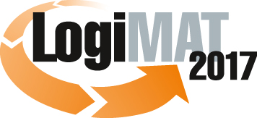

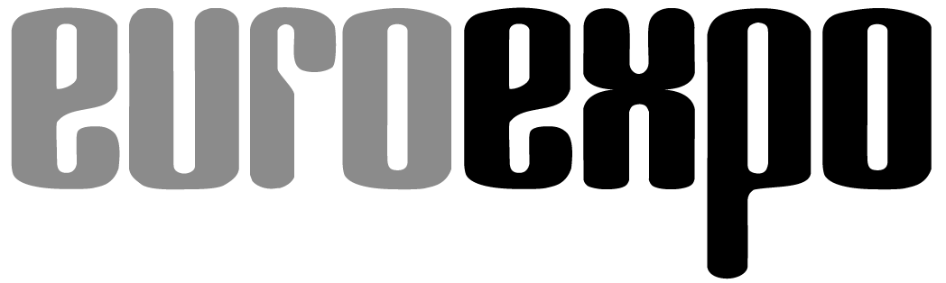

Messe- und Kongress-GmbH

Joseph-Dollinger-Bogen 7

D - 80807 München

Tel.: +49 (0)89 32391-259

Fax: +49 (0)89 32391-246

www.euroexpo.de

www.logimat-messe.de

www.tradeworld.de

**15th International Trade Fair for Distribution,**

**Materials Handling and Information Flow**

**14 to 16 March 2017, Neue Messe Stuttgart**

As part of LogiMAT



Munich, 16.03.2017

# Press Release

# LogiMAT 2017 in Stuttgart – Closing Report

**LogiMAT – No.1 platform for intralogistics**

**LogiMAT 2017, the 15th** **International Trade Fair for Distribution, Materials Handling and Information Flow, broke all records in terms of exhibitor and visitor numbers and exhibition space. This result and the broad range of exhibits from national and international suppliers positions LogiMAT firmly as the No.1 platform for intralogistics and supply chain management.**

LogiMAT 2017 closed with the best result in the 15-year history of this “International Trade Fair for Distribution, Materials Handling and Information Flow”: More exhibitors than ever before, maximum space take-up at the Stuttgart exhibition centre and a stampede of visitors: over 50,000 logistics experts crowded into the exhibition halls. “Following the fantastic result of last year, where we had a 25-percent rise in visitor numbers, this additional increase in double-digit percentages was not necessarily expected,” explained Exhibition Director Peter Kazander, Managing Director of EUROEXPO Messe- und Kongress-GmbH, Munich. “The tremendous level of interest from the international trade audience underlines the position of LogiMAT as the No.1 platform for intralogistics and supply chain management.”

1,384 exhibitors (+8.1 % cf. last year), of which almost one in four (+24.6 %) came from abroad, took up 102,100 square metres (+7.0 %) of exhibition space, breaking through the 100,000 mark for the first time. As regards the national and international exhibitors who presented their innovations, every last square centimetre at the Stuttgart exhibition centre was filled for the 15th LogiMAT. Exhibition Director Kazander emphasised in particular the high demand from international exhibitors: “In view of the many international difficulties and uncertainties for trade and business that we are experiencing at present, the presence of exhibitors from 36 countries – four more than in 2016 – was not something we took for granted.”

Already in 2016 the show´s management was able to take up all the available space at the exhibition centre with this international intralogistics trade fair – it was the first guest organizer to do so. This year, in order to do justice to the ever growing interest from exhibitors, the exhibition management made available an additional 3,000 square metres (net) of exhibition space, for example in the East Entrance area and on the gallery between Hall 1 and Hall 3. Nevertheless as early as autumn last year, the eight halls at the exhibition centre for LogiMAT 2017 were fully booked. “We can´t accommodate any more,” said Kazander. “At least not on the exhibition site as we know it from this year.” Next year the new hall at the Stuttgart exhibition centre – Hall 10 – will provide LogiMAT with a further approx. 15,000 square metres of space. “Given the high level of demand, we will easily be able to fill it, without departing from our aim of maintaining LogiMAT´s attractiveness as a compact, efficient B2B forum,” affirmed the Exhibition Director.

Kazander was particularly pleased to see another significant rise in visitor numbers. “It´s the litmus test as regards the success of a trade fair,” he said. On the three days of the show, 50,187 trade visitors (+15.4%) came to Stuttgart – 6,701 more than last year. They used the 15th LogiMAT as an information platform, as a chance to compare suppliers and as a place to make new business contacts.

The visitor survey was conducted professionally by the independent market researchers Wissler & Partner of Basel. The survey revealed that one in three visitors (32.8%) travelled further than 300 kilometres to come to the event. Around 20 percent of the visitors came from outside Germany. 52 percent of the trade audience were decision-makers from small and medium-sized companies, around 42.6 percent were actively looking to invest. One in four trade visitors (24.1%) placed corresponding orders either at the show itself or afterwards. In their overall rating, 75.8 percent of trade visitors to the intralogistics fair gave top marks or very high marks to the event. In addition, 54.1 percent of the visitors to LogiMAT described LogiMAT as “the most important intralogistics trade fair”.

Also enjoying a further rise in exhibitor and visitor interest was the competence platform TradeWorld, which was held as part of LogiMAT for the fourth time. It focuses on the entire process chain in trade and commerce, gathering together the know-how about all the processes concerned with digital trade, now and in the future. On the exhibition space around the TradeWorld platform, and at several stands in the exhibition halls, a total of 173 exhibitors (+29.1% cf. last year) presented their spectrum of products and services for integrated processes in digital trading. As such this year 12.5 percent of the exhibitors at the exhibition centre (last year 10.5%) were also showcasing innovative concepts and specific solutions for the entire process chain in trading. “For the e-commerce business and also for high-street retailing, an area that is in a process of change, it is becoming ever more important to optimise processes, in particular in logistics,” is how Dr. Petra Seebauer, Director of TradeWorld 2017 and Managing Director of EUROEXPO Messe- und Kongress-GmbH, explained the background. “Intralogistics and trade are opening up synergies for both sides. And as such the integration of TradeWorld into LogiMAT and the further growth of the competence platform for trading processes is a consistent and logical consequence.”

As a sustainable success factor for LogiMAT overall, Exhibition Director Kazander points to the trio of trade-fair concept with a supporting program of congress standard, the ideal structure of the Stuttgart exhibition centre and the mix of networking and B2B fair, and to the positioning of LogiMAT as a platform for pioneering new developments. “In terms of competence and digitalisation, technologies are merging for efficient processes in the entire supply chain,” summed up Kazander. “Many exhibitors at LogiMAT are now positioning themselves as full-service suppliers for comprehensive solutions which go beyond company borders. As such and with the enormous interest from visitors, LogiMAT is now the most important international trade fair for both intralogistics solutions and for process management in the supply chain overall.”

The next **LogiMAT** takes place in just three months time, from 20 to 22 June 2017,in Nanjing, **China**.

**LogiMAT 2018** in Stuttgart takes place from 13 to 15 March 2018.

Further information: [www.logimat-messe.de](http://www.logimat-messe.de) and [www.tradeworld.de](http://www.tradeworld.de)

*Munich – Reproduction free of charge. Copies of publication to:   
EUROEXPO GmbH, Presse- und Öffentlichkeitsarbeit, 80912 Munich, Germany.*

**Exhibitor Statements**

**Importance of LogiMAT**

“As an exhibitor right from the very first event, this trade fair has a special role for us. This year we had a large number of high-calibre visitors from almost all sections of industry visiting us at our stand.”

**Lars Beuel, Marketing Director, National Hubtex, Fulda, Germany**

“Everybody who is involved in the themes of supply chain and logistics comes together at LogiMAT. The highly professional trade audience comes to this event with specific issues and to review the many products and solutions on display at this compact, efficient forum. All the exhibitors can present themselves here at eye level with each other – that´s the right concept.”

**Jürgen Hess, CEO, Miebach Consulting, Frankfurt am Main, Germany**

“For us LogiMAT is right on trend. We note that more and more of our customers are coming to Stuttgart. Because this is where the decision-makers are – and that is not always the case at other fairs.”

**Dennis Maurizio, Regional Sales Director, Prodinger Verpackung, Coburg, Germany**

“LogiMAT is the European sector fair for intralogistics – from year to year it increases in internationality, it has rising visitor numbers, a rising number of leads. As things look today, in 2018 we will only be looking at LogiMAT as a sector trade fair for intralogistics.”

**Peter Müller, Head of Conveyor Technology & Automotive at Siemens, Erlangen, Germany**

“A trade audience that comes along looking for solutions to specific projects, and the right decision-makers in one place – LogiMAT is the No.1 meeting place in Europe for intralogistics. This trade fair will carry on growing in attractiveness.”

**Philip Mylle, Head of Affiliate Sales Stow International N.V., Belgium**

“High praise! LogiMAT really is getting better every year. For us it is now the most important trade fair, and one where we were able to present in detail three of four products from the PSI Logistics Suite, to a competent trade audience, which this year was even more numerous than before.”

**Dr. Giovanni Prestifilippo, Managing Director, PSI Logistics, Berlin, Germany**

“LogiMAT has again put in an impressive performance, again it brought together a broad trade audience and was able to extend the successes of previous years.”

**Dr. Henry Puhl, CEO, Still, Hamburg, Germany**

“For us LogiMAT is the most important trade fair, it is our main fair. This is where we meet the trade visitors from our target groups from the German and European market. It´s a very lively fair and we feel at home here.”

**Andreas Schiermeyer, Director of Advertising and PR, Stöcklin Logistik, Aesch, Switzerland**

“LogiMAT has for some time been a trade fair where we are kept busy with visitors at our stand all the time. Every year that we take part it is ever more beneficial to us.”

**Stefan Schmidt, Head of Communication and Marketing, Fraunhofer IML, Dortmund, Germany**

“For us LogiMAT has always been the No.1 trade fair for logistics. This year it surpassed even the already high expectations.”

**Oliver Schuck, Head of Digital Supply Chain & IoT at SAP Deutschland, Walldorf, Germany**